BURTON BOROUGH SCHOOL

PARENT AND STUDENT
EXAMINATION INFORMATION BOOKLET
2017 – 2018

School Exam Centre number 29145

Name…………………………………………………………………………

Tutor Group…………………………………………………………..

School……………………………………………….

INTRODUCTION

The aim of this guide is to help you get through the examination period by explaining the procedures and by answering some of the questions you may have.

Read it carefully, if you are still not sure about anything ask your form tutor, Examinations Officer or a member of SLT.

CONDUCT
At The Burton Borough School, we expect the highest standards of behaviour during all examinations, from every student. Any misconduct will be reported to the examination boards and will be dealt with severely. It may even result in you being disqualified from all further GCSE examinations.

Please do not write on the examination desks. This is regarded as vandalism and you will be asked to pay for any damage. Do not draw graffiti or write offensive comments on examination papers.
If you do the examination board may refuse to accept your paper.

You will also be charged for the removal of chewing gum from the chairs, tables or carpet so make sure you dispose of it in the bin prior to entering the exam room.

Full school uniform must be worn by all students attending school for examinations.

Candidates not in uniform will be turned away and not admitted to the exam room until they are suitably dressed.

BEFORE YOU SIT YOUR EXAM

Your teachers have to inform the examinations officer which examination you need to be entered for. Before it is sent off to the examinations boards, you will be given a piece of paper with all your personal details and exams listed.

YOU MUST CHECK IT VERY CAREFULLY

Any mistakes that are not picked up at this stage will be either very expensive to correct or at worst, may result in you getting no result for your exam.

The things to check are:

Your personal details as this is how they will appear on your certificates
- Correct spelling of your name.
- Correct date of birth.
- Examination units you are taking.
- Level of the paper
  - e.g. Foundation (F) or Higher (H).

Check your exam entry with your teacher. If you are entered for the wrong exam, you will be given the wrong paper. If anything is incorrect, you must write the correct spelling or exam on the paper and tell the examinations officer IMMEDIATELY.

.

DURING THE EXAMINATION PERIOD

Candidates need to be ready at the assembly point rather than going to CLL / Assembly:-

WHEN?
Morning examinations start at 9.00a.m.
Be outside the sports hall for 8.40am at the very latest.

Afternoon examinations start at 1.30p.m.
Be outside the sports hall for 1.10pm at the very latest.

WHERE?

Normally all your examinations will take place in the Sports Hall, occasionally other rooms may be used so check your exam timetable. You enter the examination room through the front doors of the Sports Hall when told to do so. You will be given instructions about where to leave your bags, coat etc.

Your photo identification card with your examination number will be placed on a desk. Do not be intimidated by this, it is so you can be identified by the exams staff as required by the exam boards. You need to find your place and sit down in silence.

EACH EXAM MAY HAVE A DIFFERENT SEATING PLAN

The seating plans and start times will be clearly displayed in the windows of the Sports Hall on the day of the exam.

DO NOT DISTURB THE REST OF THE SCHOOL AT THE START OF ANY EXAMINATION

ENTERING THE EXAM ROOM

- You must be silent.
- Your pockets should be empty. Empty any pocket contents into your bag before entering the examination room
- You must not communicate with any other student in ANY WAY
- No eye contact or grinning at another student, this can be counted as communicating.
- Do not pass anything to another student in an examination.
- Do not borrow anything from another student whilst in the exam room.

REMEMBER TO BRING:

- Drinking water in a CLEAR BOTTLE with NO LABEL.
  - No other drinks are allowed

- Your normal writing materials and calculator, when applicable, to the exam in a CLEAR PENCIL CASE or CLEAR PLASTIC BAG.
  - We recommend that you have 2 Pencils, 2 Black Pens (no Gel pens or erasable pens, Biro only), a ruler, a rubber, a pencil sharpener, a protractor, a compass and a scientific calculator. This is deemed as BASIC EQUIPMENT that you need every day in school and so you will be expected to bring it to your exams. We have very few spares and so if you fail to bring your own equipment you may have to go without.

Exam kits containing the above can be purchased from the exams office for £1 and scientific calculators for £6 from the Maths Dept.
Calculators must be:  o of a size suitable for use on the desk;  o either battery or solar powered;  o free of lids, cases and covers which have printed instructions or formulas. | - Calculators must not:  - be designed or adapted to offer any of these facilities: -  - language translators;  - symbolic algebra manipulation;  - symbolic differentiation or integration;  - communication with other machines or the internet;
The candidate is responsible for the calculator’s power supply and its working condition  LEAVE AT HOME: | - be borrowed from another candidate during an examination for any reason;  - have retrievable information stored in them - this includes:  - databanks;  - dictionaries;  - mathematical formulas;  - text.

- MOBILE PHONE,
- IPOD,
- MP3/4 PLAYER,
- SMART WATCHES including iWatch
- PAGER or any other products with text digital facilities
- Any web enabled sources of information
- Unauthorised books or rough paper,
- Noisy jewellery as this may disturb other candidates

Any phones, iPODs, MP3s, Smart watches or any other products with text digital facilities must be removed from the candidate’s person. Any phones must be switched off BEFORE entering the examination room and held securely in the candidate’s bag at their own risk. . The examination boards wish to make it clear to all students that taking mobile phones , iPods, MP3/4 players, Smart watches, pagers, any other products with text digital facilities, electronic communication storage device, web enabled sources of information or digital facility or any other unauthorised electrical device to an examination desk is STRICTLY FORBIDDEN.

- If any student is found to have a mobile phone on his or her person and it is switched off, that candidate will receive ZERO MARKS for that examination paper.
- If a student has a mobile phone on his or her person and it rings during the examination, that candidate will be DISQUALIFIED FROM THAT EXAMINATION SUBJECT.
- If a student leaves a mobile phone at the front of the examination room, and it is left on and rings, the candidate will be DISQUALIFIED FROM THAT EXAMINATION SUBJECT
Please be aware that any infringement of this rule will be reported to the relevant examination board. Do not risk failing an exam by forgetting. There are no exceptions!

LEAVE MOBILE PHONES, IPODS, MP3/4 players, Smart watches and all other devices with text/digital facilities or electronic communication/storage devices or digital facility AT HOME.

Whilst in the examination room all candidates are asked to remove watches from their wrists and place them on the desk. NO internet enabled device can be placed on the candidate’s desk.

NO EXCEPTIONS WILL BE MADE.

YOU CANNOT:

- Leave an examination early,
- Leave to go to the toilet (except under special considerations) so make sure you go before the exam starts.
- Go and fetch something you have forgotten. i.e. glasses,
- Ask the invigilators questions relating to the content of the exam,
  - However, if you think there is something missing from your paper, ask for guidance.
- Enter the room with writing on arms. Anyone trying to do so will be required to wash it off before they can sit the exam. Should this make you late, you will be treated as a late arrival.

REMEMBER

- Only write in black ink.
- Only use pencil for diagrams.
- Do not write in any other colour.
Do not use correction fluid - if you make a mistake cross it out and carry on.

WHEN YOUR EXAM HAS FINISHED

When your exam has finished and your papers have been collected in, you will be told you can leave the exam room, a row at a time. Other students may still be working in the room so you must leave in silence. Once you have been dismissed from the exam room, you can go back to normal lessons.

DO NOT DISTURB THE REST OF THE SCHOOL AT THE END OF ANY EXAMINATION.

WHAT IF . . . .

I forget to come for an exam?

You can only take an exam at the set time, so if you forget to come, you have missed the exam. If you miss a GCSE exam you will be charged a minimum of £35.

I am late?

If you arrive after the published start time you must report to reception and wait to be escorted to the exam room by the exams officer. Each candidate who arrives between 5 – 20 minutes late will be considered on an individual basis regarding late entry to the exam room. Anyone arriving late without good reason will NOT BE ADMITTED. Candidates will only be allowed into the room after 20 minutes have passed in exceptional circumstances. You are entitled to have the full time allowed.

I am ill?

If you are ill, you must try to sit the exam. Your parents must telephone the school by 8.00am on the morning of the exam for advice.

If you are unwell, but attend the exam, your parents must write a letter to the Examinations Officer explaining the situation, accompanied by a doctor’s note.

Exam Timetable Clash

It is not unusual for candidates to find they have a clash on their exam timetable. If there is a clash of two papers it is normal for the candidates to sit one paper, and then have a short break in the exam room (5mins) and then continue with the next paper. Where there is a clash of 3 or more papers throughout the day, we will arrange supervision for breaks and create an individual time table for such candidates. Please speak to the exams officer straight away to initiate the arrangements. It will be essential for the candidate to bring a packed lunch with them on the day; this will be kept secure until the specified lunch break.

AFTER THE EXAM PERIOD

How do I get my results?

GCSE: results day is:-

Thursday 23rd August 2018 for exams taken in May/June 2018.
  - Year 11s can collect their results from school between 10 a.m. and 12 noon.

IF YOU ARE COLLECTING YOUR RESULTS IN AUGUST

- An envelope will be waiting for you with your name and candidate number on. All of your results will be in the same envelope.
- We do not e-mail, give results over the phone, or give them to a friend or relative to deliver to you without your authorisation. If you wish someone to collect them for you, you must send a note explaining that you give permission for that person to take your results. If you want them posted to you, you must provide a LARGE LETTER sized STAMPED ADDRESSED ENVELOPE.

ENQUIRY ABOUT RESULTS

Costs and application forms are also on the school website for you to download and complete. All cheques are to be made payable to Burton Borough School

ENQUIRIES ABOUT RESULTS

If you would like to make an enquiry about your result (a review of marking), there are 3 possible outcomes:

- Your original mark will be confirmed as correct and there will be no change to your grade.
- Your original mark may be raised and this may or may not result in a change of grade.
- Your original mark may be lowered and this may or may not result in a change of grade.

In order to proceed with the enquiry you must fill out the consent form available from the exams office and return it to the examinations office with the correct fee. The consent form tells the exam office staff that you have understood what the outcomes could be and that you are happy to proceed.

NO APPLICATIONS CAN BE PROCESSED WITHOUT THE CORRECT FEE OR CANDIDATE AUTHORISATION.

CERTIFICATES

Your examination certificates will be available at the Awards Evening in the autumn term or by collection from the school from 1st December.

If you are concerned about any aspect of your results, you must see your subject teacher. The school will only distribute the results for examinations sat at school.

IT IS VERY IMPORTANT that you collect your certificates as they are valuable documents. They will be kept for 12 months unless collected before. After this time the school, as directed by JCQ, are allowed to either send the certificates back to the board or destroy them.

Certificates are important documents and must be kept safely. Replacement certificates are available from the exam board, however, you may be charged anything up to £30 or more for a replacement.

FINALLY . . . .

Your exam results represent all the hard work you have put in at school. It is very important that you give these exams your full attention and focus on doing the very best you can.

- Do not behave in any way that might jeopardize your chances or those of other people in the exam room. Even eye contact can be taken as communication.

- Examination Board rules are strict and must be followed to the letter.

- Any misbehaviour WILL be reported to the Board and will ALWAYS be dealt with very severely.

- Keep this booklet in a safe place.

- Please show this booklet to your parents and ask them to sign below to say that they have understood the mobile phone rules and consequences.

EXAMINATIONS GUIDE FOR PARENTS

Introduction

Your child will soon be sitting important public exams, which are stressful for students and probably even more for their parents. This leaflet has been designed to give you some advice on how you can help your child achieve their best. It is not easy to watch your children suffer and not to know what you can do to help. The students who do best in exams:

- have revised thoroughly and carefully
- feel confident
- have parents who take an interest in their revision.
Please keep this guide safe, as it will be required over the next two years. Copies of all the Exam’s Documentation/Calendars mentioned in this guide (including this guide) can be found on the School’s website. If you have any questions regarding exams, however small, please contact Lisa Richardson, the exams officer.

Before the Exams

At the start of the exam season your child will be given a statement of entry to check and sign. This will tell you and your child exactly which examinations they have been entered for. Check it carefully for exam clashes, correct subjects and correct tier of entry. If you are at all unsure please ask, it is much better to sort out problems at this stage, rather than on the day of exam! Later on, the final statement of entry will be sent to you showing any changes (if applicable) together with a timetable showing rooms and exact times. Read through the ‘JCQ Notice to Candidates’ and the ’Regulations and Guidance for Examinations – Instructions to Candidates’ that have been sent to your child, this will give you lots of extra information.

Revision – so what can you do?

Do
- Offer help as a tester; as a reader; as a source of knowledge; as a buyer (of equipment, books, rewards)
- Make them feel you are on their side
- Organise non study activities for them
- Encourage them with praise and rewards
- Work out time limits with them – make sure they take breaks at least every 90 minutes
- Make their environment revision friendly – somewhere quiet with good natural light
- Ensure any other children you have understand the importance of revision time
- Re-assure them that you are concerned about their welfare more than the results

Do not
- Force them to revise in ways you think best
- Get involved in their stress; don’t shout back
- Make comparisons with other students or yourself at a younger age
- Give them permission to do badly
- Believe the revision tales , i.e. it’s too early to start revision
Time Management

- Some is better than none; a lot is better than too much.
- It is unwise to do too much on one day and none on another.
- Your concentration span is constantly changing. It depends on the time of day, what you’re doing and what you’ve done before. Half an hour is an accepted average before you need a change of activity. Sometimes it’s ten minutes, sometimes three hours.
- Students should have one day a week free from revision, as long as they work eight hour days the rest of the week.
- Breaks are essential, even a short 20 minute break every 90 minutes will refresh your child’s mind.
- Walking, the sea and fresh air are good for the brain. Students always forget that.
Active Learning

Variety, novelty and activity are the friends of the reviser. They keep the brain alert and fend off the worst enemy; stress-induced boredom. Sitting reading and rereading a book or a note book is often the worst form of revision; the mind blurs, the pages drift together, anxiety about the exam takes over the mind. But too many students think it’s the only revision that counts and so waste far too much time looking at pages instead of revising.

Exam Days

- Have a copy of the timetable displayed somewhere in the house so you know when they have an exam
- Make sure they are dressed in school uniform
- Make sure they have the correct equipment they need for an exam
- Make sure they have a bottle of water – in a clear plastic container with all labels removed.
- Remind them to leave their mobile phone (or any other electronic devices) at home.
  - It is against Exam Regulations to bring them into an exam room and can lead to disqualification.
- Make sure they don’t revise too late the night before.
- Make sure they have set their alarm.
- Make sure they eat breakfast – even if they don’t feel like it, a little will help
- Tell your exams officer of any family crisis that may affect your child’s exam performance.
- Tell your exams officer of any medical conditions, for example hay fever, that may affect your child’s performance. There are special considerations for some conditions.
In the unlikely event that they do not turn up for an examination, please ensure your contact details are up to date or leave a telephone number with the exams office so that we can contact you or your child.

YOU MUST CONTACT THE EXAMS OFFICE IMMEDIATELY IF YOUR SON/DAUGHTER CANNOT ATTEND AN EXAMINATION – AND REMEMBER MEDICAL PROOF WILL BE REQUIRED BY THE EXAMINATION BOARD IF YOU REQUIRE SPECIAL CONSIDERATION.

Top 12 tips from one group of concerned parents to the next:

- A dedicated quiet space with good natural light or lighting is best for studying, with no distractions. If you have other children who are not studying for exams, make sure that they know the importance of revision time.
- Ensure that your son or daughter has one evening a week away from their studies. It’s also important that they take regular breaks during the study periods.
- Be around as a 'feeding station' – feed your child lots of healthy food and proper meals - not too many sugary snacks and junk food.
- Offer to help with testing or ask if there is something that you can do for them.
- Reassure them you are concerned about their welfare as well as the results.
- Know your son or daughter's revision timetable. Encourage them to tell you about what they are studying. If you know that they are not at their best first thing in the morning, encourage them to rest then and work when they are more lively. They should choose their weakest/sleepiest time of day to be sociable and go out, or watch TV at those times.
- Know exactly the date, time and location for each exam and incorporate this into the revision plan.
- Make sure that they have the correct equipment they need for the exam (calculators, rulers etc). Know what they are not allowed to take in to the exam (mobile phones, pagers etc).
- If your son or daughter has a medical condition, for example diabetes or hayfever, make sure that the school knows about it. There are special considerations for some conditions.
- If there is a family crisis, for example divorce or bereavement, again ensure that your son or daughter's teacher knows about it, since the additional stress can affect your child's exam performance.
- Make sure that your child is using the internet to study and not as a resource to give the appearance of study!
- Tell them that they can only try their best and even if they don't do as well as you'd hoped, you still love them just as much.

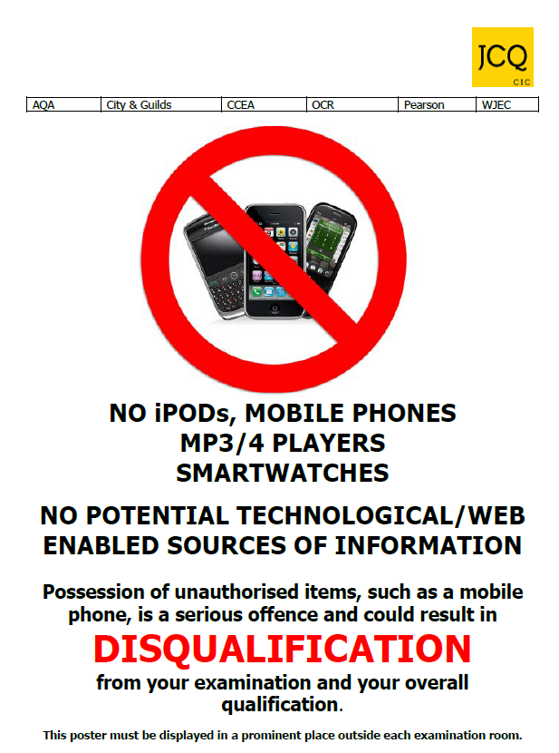

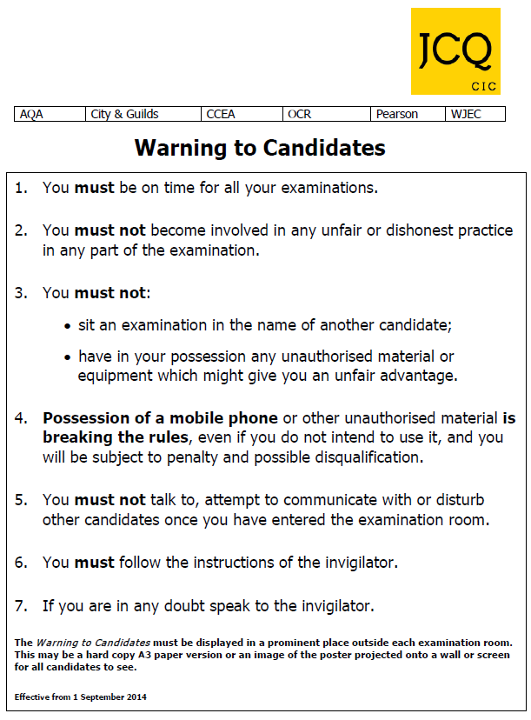

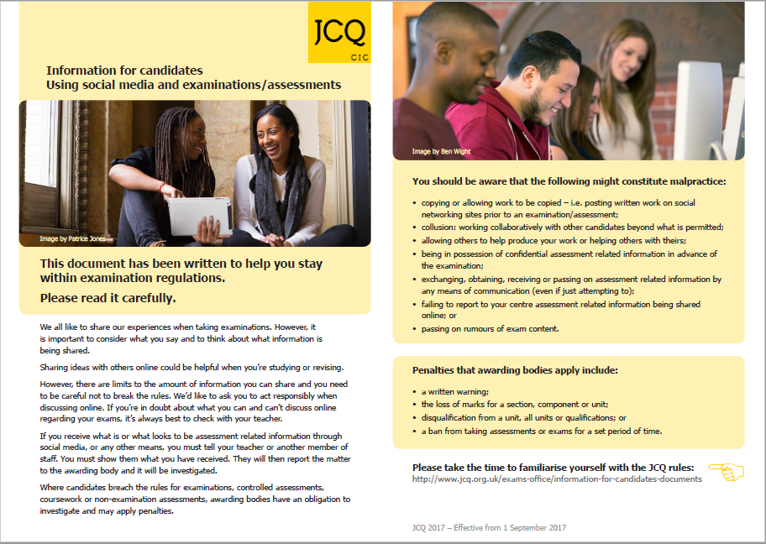

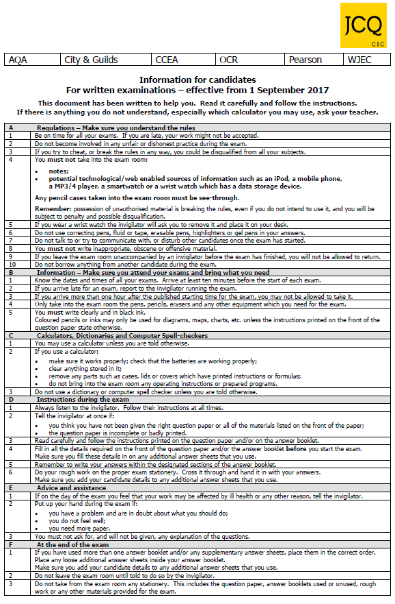

Please sign and return the attached slip to the Exams office.

- I understand that I will be asked to remove my watch from my wrist and place it on the exam desk I am sitting at , where it will remain until the exam is concluded.

- I understand the mobile phone/IPOD/MP3/4 /internet enabled devices regulations and confirm that I am aware of the consequences.

- I understand the consequences of not adhering to the Exam conduct regulations as directed by JCQ.

- I understand that I will need a black pen, ruler and pencil in a clear plastic case for ALL exams.

Signed _______________________________________________Dated ______________

Tutor Group_____________

(Student)

Parent / Guardian of ________________________________________________

Signed _____________________ Dated _______________

(Parent)

